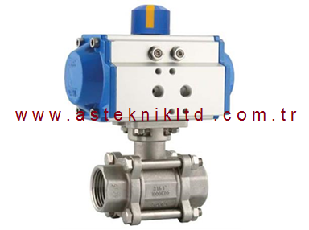

ÜRÜN ÖZELLİKLERİ

|  |
| --- |
| **TORK-PAV 903.DA Çift etkili pnömatik aktüatörlü paslanmaz 2/2 yollu küresel vana** |

|  |  |  |  |  |  |
| --- | --- | --- | --- | --- | --- |
| **vana ölçü** | **sipariş tip no** | **yol ad.** | **basınç** | **sıcaklık** | **ISO bağ. flanş** |
| 1/2" | TORK-PAV903.15DA | 2/2 | 0-40 bar | 0..150 C | F03 |
| 3/4" | TORK-PAV903.20DA | 2/2 | 0-40 bar | 0..150 C | F03 |
| 1" | TORK-PAV903.25DA | 2/2 | 0-40 bar | 0..150 C | F03 /F04 |
| 11/4" | TORK-PAV903.32DA | 2/2 | 0-40 bar | 0..150 C | F04 /F05 |
| 11/2" | TORK-PAV903.40DA | 2/2 | 0-16 bar | 0..150 C | F04 /F05 |
| 2" | TORK-PAV903.50DA | 2/2 | 0-16 bar | 0..150 C | F05 |

|  |
| --- |
| **TORK-PAV 903.SR Tek etkili pnömatik aktüatörlü paslanmaz 2/2  küresel vana** |

|  |  |  |  |  |  |
| --- | --- | --- | --- | --- | --- |
| **vana ölçü** | **sipariş tip no** | **yol ad.** | **basınç** | **sıcaklık** | **ISO bağ. flanş** |
| 1/2" | TORK-PAV903.15SR | 2/2 | 0-40 bar | 0..150 C | F03 |
| 3/4" | TORK-PAV903.20SR | 2/2 | 0-40 bar | 0..150 C | F03 |
| 1" | TORK-PAV903.25SR | 2/2 | 0-40 bar | 0..150 C | F03 /F04 |
| 11/4" | TORK-PAV903.32SR | 2/2 | 0-40 bar | 0..150 C | F04 /F05 |
| 11/2" | TORK-PAV903.40SR | 2/2 | 0-16 bar | 0..150 C | F04 /F05 |
| 2" | TORK-PAV903.50SR | 2/2 | 0-16 bar | 0..150 C | F05 |